**Promoting the filling of perovskite material in the scaffold layer to improve the conversion efficiency of printable perovskite solar cells**

Weiwu Dang1,2, Li Liu2, Jianhua Chen2, Xian Gu2, Xuhao Wang2, Xiaolan Li2,

Yan Li2, *

1College of Intelligent Manufacturing, Shaanxi Institute of Technology, Xi'an, Shaanxi 710300, China

2College of New Energy, Xi’an Shiyou University, Xi'an, Shaanxi 710065, China

* Correspondence to: Doc. Yan Li, College of New Energy, Xi’an Shiyou University, Xi'an, Shaanxi 710065, China

*E-mail address*: li1988yan@163.com

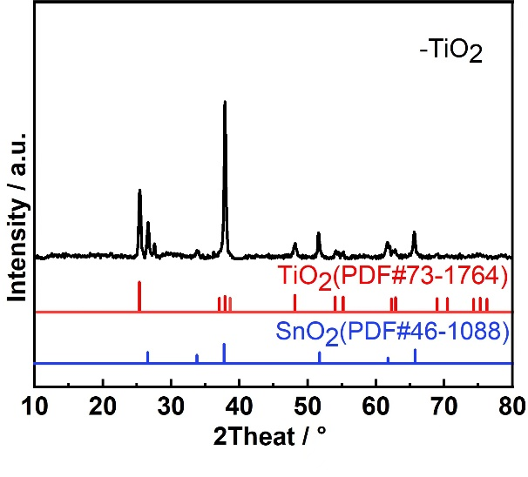 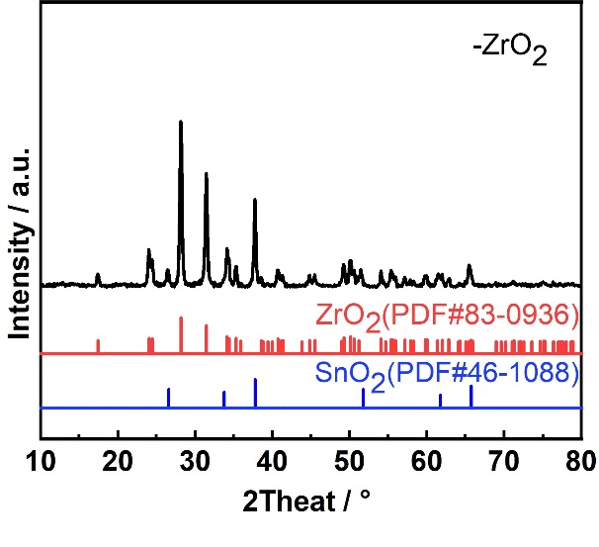

Figure S1 XRD patterns of the films deposited on the FTO substrate: (a) TiO2 film and (b) ZrO2 film

C:\Users\HP\Desktop\低倍2.00KX未填充.tif C:\Users\HP\Desktop\高倍5.00KX未填充.tif

Figure S2 Cross-sectional views of the TiO2/ZrO2 scaffold film: (a) low magnification and (b) high magnification

Table S1 Detailed measurement results of the element distribution of the MAPbI3 in the TiO2/ZrO2 scaffold film in Figure 1

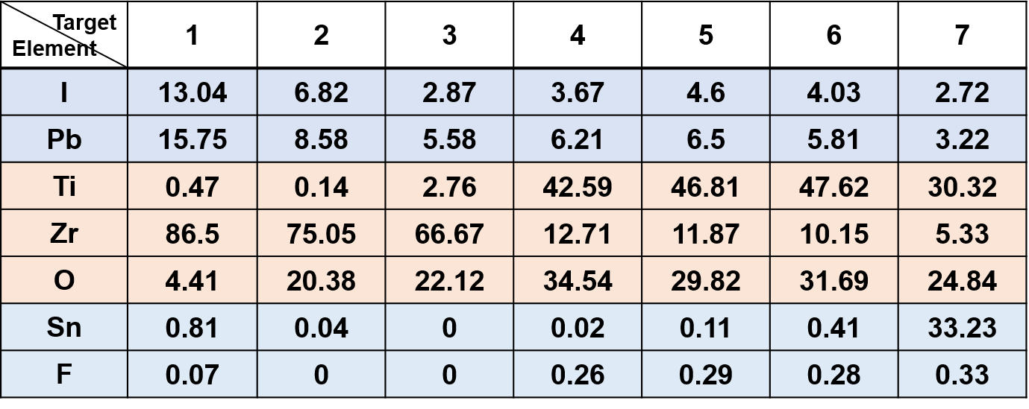



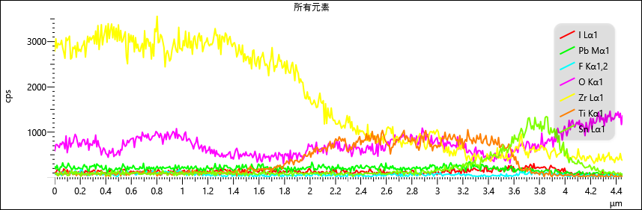

Figure S3 Line scan results of the EDS of MAPbI3 filled into the thin TiO2/ZrO2 scaffold film

**The method for determining the optimal addition amount of PS microspheres (Ignore the boundary effects)**

To regulate the pore structure of the TiO₂/ZrO₂ scaffold layer, PS microspheres are proposed as an additive. By controlling the addition amount of PS microspheres, the size and quantity of pores can be adjusted. The specific amount of PS microspheres is determined through modeling and calculation. The selection criteria for the optimal calculated results are as follows: ensuring maximum filling of perovskite material while maintaining the structural integrity of the TiO₂/ZrO₂ afforld layer without collapse.

As shown in Figure S4, the original area of the TiO₂/ZrO₂ scaffold layer is 10 mm × 10 mm, with a thickness of approximately 8 μm. Since the length of 10 mm is significantly larger than the thickness of 8 μm, this substantial size difference poses challenges for constructing a model of the TiO₂/ZrO₂ scaffold layer. Therefore, the method adopted in this study is to divide the side length into n equal parts and select one segment, ensuring that the length and thickness of the TiO₂/ZrO₂ scaffold layer are of the same order of magnitude. When n = 104, a cross-sectional model with a length of 1 μm and a thickness of 8 μm, as shown in Figure S4, can be established.

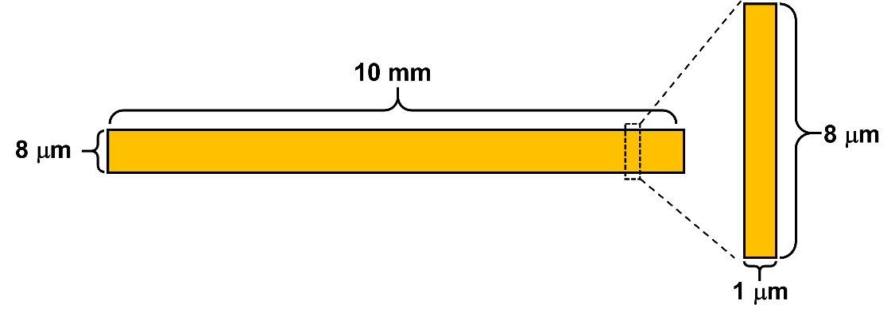

Figure S4 TiO₂/ZrO₂ scaffold layer with the length of 10 mm and thickness of 8 μm is divided into n equal parts. When n = 104, a cross-sectional model with a length of 1 μm and a thickness of 8 μm can be established

As shown in Figure S5, by removing 5%, 10%, 15%, 20%, and 25% of the cross-sectional area and placing PS microspheres in the vacated regions, the number of PS microspheres that can be accommodated is calculated. These PS microspheres are then uniformly distributed within the model area. The average distance between the PS microspheres is calculated, and a noticeable reduction in the average distance indicates that increasing the addition of PS microspheres is effective. This process is repeated until the structure of the TiO₂/ZrO₂ scaffold layer collapses.

For example, when PS microspheres occupy 25% of the cross-sectional model area, the number of PS microspheres can be calculated as: Number of PS microspheres=, where the 1000×2000 nm2 represents that the area of the 25% TiO₂/ZrO₂ scaffold layer, and the π×300×300 nm2 represents the area of a PS microspheres.

The calculated number of PS microspheres is then manually and evenly distributed within the model area, as shown in **Figure S5**.The average distance between the PS microspheres is measured (as illustrated in **Table S2**. A noticeable reduction in the average distance indicates that increasing the PS microsphere addition is effective. However, when the occupied area reaches 30%, the distance between the PS microspheres becomes excessively small, leading to structural collapse of the TiO₂/ZrO₂ scaffold layer.

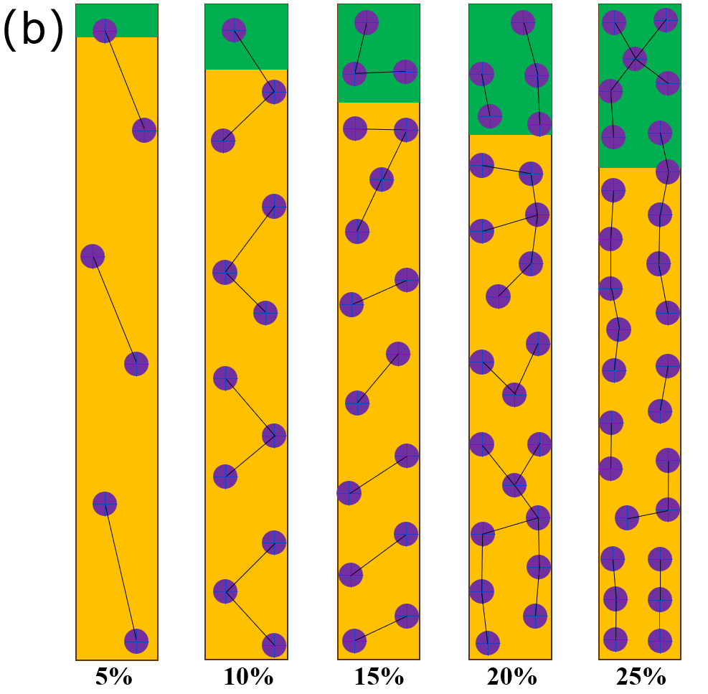

Figure S5 Series area amount of the TiO₂/ZrO₂ scaffold layer has been substituted by the equal amount of the PS microspheres, and the PS microspheres are uniformly dispersed in the TiO₂/ZrO₂ scaffold layer.

Table S2 similar calculations can be performed to obtain results for other percentages

|  |  |  |  |
| --- | --- | --- | --- |
| Relative Area Ratio (%) | Number of PS Microspheres | Average Distance (nm) | Structural Stability |
| 5 | 6 | 2973 | Stable |
| 10 | 12 | 1658 | Stable |
| 15 | 17 | 1493 | Stable |
| 20 | 23 | 1374 | Stable |
| 25 | 29 | 1128 | Critical Stability |
| 30 | − | − | Structural Collapse |

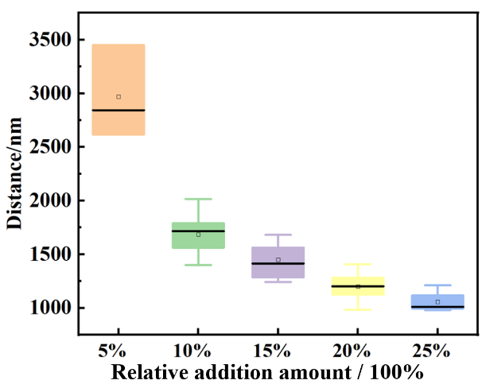

Figure S6 Average distance between microspheres when they are random distributed in the TiO₂/ZrO₂ scaffold layer

In the initial formulation for preparing the TiO₂/ZrO₂ scaffold layer, 1.5 g of TiO₂ powder and 2.5 g of ZrO₂ powder are used. When the volume of PS microspheres occupies 25% of the total volume of the two films, and given the density of the PS microspheres, the mass of PS microspheres to be added to the original TiO₂ and ZrO₂ slurries is calculated as **0.1155 g** and **0.0739 g**, respectively.



Figure S7 Cross-sectional view of TiO2/ZrO2 scaffold with 25% porosity added

Table S2 Detailed measurement results of the element distribution of the MAPbI3 in the En-TiO2/ZrO2 scaffold film of Fig.5

